Hello, welcome back on blog for day now in this we will discuss about Environment and creation of project

Chapter 3

Environment

Typescript created by Microsoft and Visual studio code also so we use VS code more often

Install VS Code

Install Nodejs- Server side framework, when we create project of Angular there will be so many packages to manage them we need NPM

Node Package Manager(NPM)

Open nodejs command prompt and check ‘node -v’ And ‘npm -v’

After installing nodejs, NPM Automatically installed.

CLI needs NPM AND NPM needs Node Js

Angular CLI- npm install -g @angular/cli

Check ‘ng -v’

Following screen should be visible

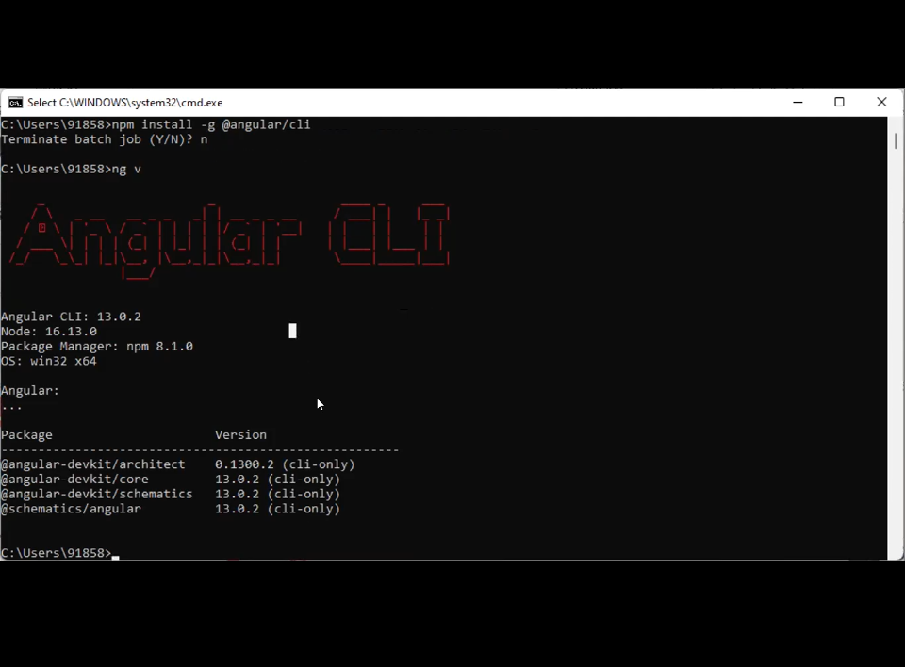

If Already Node version is there then?(100% interview) To check if you have really worked on angular or not

1. Delete nodejs folder first
2. Go in C drive > Users > App data name> Roaming> Npm(Delete it) 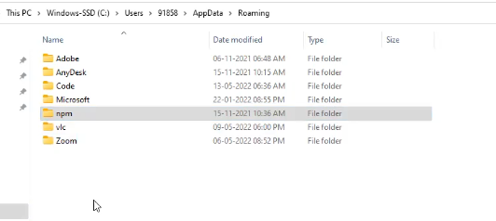

Project creation

Ng new ‘myangularapp’

It will ask question about routing now since angular 7 it is giving routing

Now open vs code

Open folder in VS code

Now run project ng serve and localhost:4200 will be by default page

Building application/Publishing application (server publishing)

This will show you have really worked on Angular

Ultimately project will be converted into js(javascript)

Ng build <project> -> directly production

On production only 5 files will be there

1. Main.ts -> start with this,
2. Polyfil.js-> for running project in older browsers
3. Style.js->styles
4. Runtime.js-> component,module,service,pipes will be here
5. Vendor.js->angular specific libraries

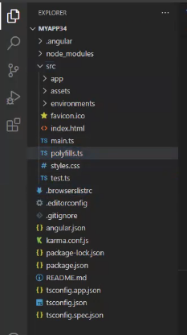

1. .angular-created via node module
2. Node module- install so many packages, npm created this
3. Package.json/ package-lock.json – it will have dependencies, version ,devdependencies
4. Src/app- everything will be created by user here
5. Assets- all images or third party icons will be here
6. Environment- for servers connection
7. Favicon.ico- it is used for main icon
8. Jasmine karma is used for testing(automation testing by devs)
9. Angular.json- all files are there with paths
10. Tsconfig.json- strict: false (Make this change)

Chapter 4

Component

It is simple typescript class in which you can create your own methods and properties

Code reusability can be achieved, Component is directive when we load on some other building block

Create component- ng g c student

Now check in app.module.ts studentcomponent should be there

@Component is decorator

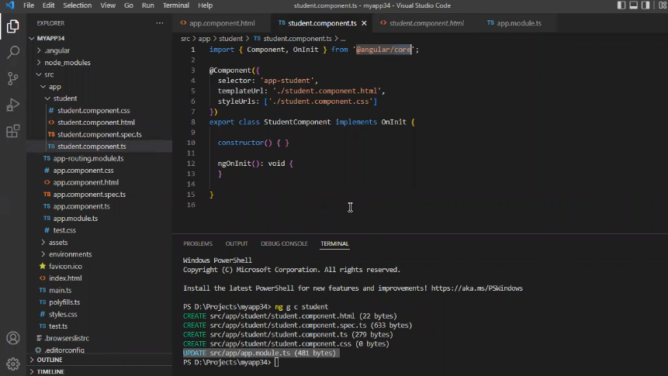

1. Importing core library
2. @component({

Selector: from-how-tocall

Template:html

styleUrl:style

})

export class

{

Constructor(){

}

}

Above constructor will automatically called because of decorator without creating any object

Types of decorators

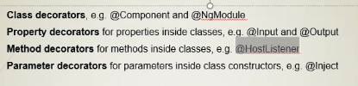

1.Selector will give address and design to call itself <app-root>- dom treats this as HTML Element when you add . in any selector then confusion will occur and DOM will treat as class so page will not be loaded

Ex-selector: ‘app-root’ -> element

Selector: ‘.app-root’ -> class(not work)

Selector: ‘[app-root]’ ->attribute(not work)

Selector, templateurl, styleurl, preservewhitespace are metadata’s